TEST SUMMARY REPORT-DEMO BLAZE

1.PROJECT INFORMATION
- Project Name: Demo Blaze
- Module Tested: Signup, Login, Home, About Us
Product page, Add to Cart, Checkout, Logout
- Test Cycle: Cycle 1
- Build Version: 1.0
- Test Environment: Windows 10,Chrome Browser

2. TESTING SCOPE

MODULE | FEATURED TESTED | FEATURED NOT TESTED
- Sign up | - User Interface  - Field validation(username and password)  - User registration with valid credential  - Functional testing  - Error message validation  - Security Testing | - Validation
- Login | - Valid credentials  - Invalid credentials  - Empty field  - Error message validation | - Password recovery
- Product page | - Product listing & category filtering  - Product details navigation  - Sorting functionality  - Positive and negative scenario | - wish list
- Add to cart | - Adding products to the cart  - Removing products from the cart  - Updating quantity  - Cart badge count & display | - Promo code
5.Checkout/place order | - Field validation(name,country,city,credit card,year)  - Order confirmation  - Popup validations  - Positive & negative scenarios | - Payment gateway
6.Contact | - Contact form submission  - Field validation(name,email,message)  - Positive & negative scenario | - Auto reply
7.Log out | - Field validation  - Log out from different pages  - Positive & negative scenario | - Auto logout

3. TEST EXECUTION SUMMARY

Module | Total test case | Executed | Passed | Failed | Blocked
Home | 19 | 19 | 19 | 0 | 0
Sign up | 39 | 39 | 28 | 11 | 0
Login | 34 | 34 | 31 | 3 | 0
Product page | 20 | 20 | 20 | 0 | 0
Add to cart | 26 | 26 | 22 | 4 | 0
Checkout | 50 | 50 | 27 | 23 | 0
contact | 11 | 11 | 4 | 7 | 0
Log out | 6 | 6 | 6 | 0 | 0
About us | 10 | 10 | 10 | 0 | 0

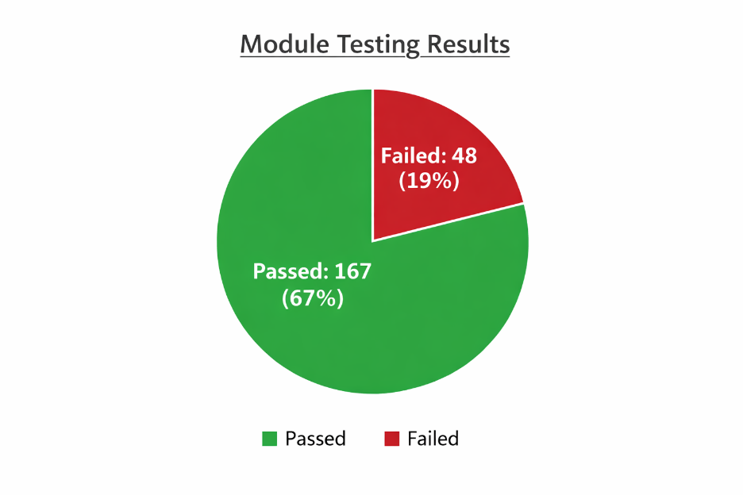
Total cases executed | Passed | Failed
215 | 167 | 48

4.DEFECT SUMMARY

module | Total defects | critical | major | minor
Sign up | 10 | 5 | 4 | 3
login | 3 | 0 | 0 | 0
add to cart | 4 | 1 | 2 | 0
Check out | 23 | 11 | 10 | 5
Contact | 7 | 2 | 4 | 1

5.REQUIREMENT COVERAGE

Requirement ID | Requirement Description | Status
REQ-001 | User can register with valid credential | covered
REQ-002 | User can login with valid username and password | covered
REQ-003 | Login fails with invalid credential | Covered
REQ-004 | Product listing displays all products | covered
REQ-005 | Product details are accessible from listing | covered
REQ-006 | User can add products to the cart | covered
REQ-007 | User can remove products from the cart | covered
REQ-008 | Check out validates mandatory filed | covered
REQ-009 | Successful order confirmation message | covered
REQ-010 | Contact form validates all fields and submits successfully | covered
REQ-011 | User can log out | covered

6.RISK & ISSUES
RISKS & ISSUES
- Cart badge count not auto-updated
- Checkout field validation issues
- Leading /trailing space in signup and login

7.QUALITY ASSESSMENT

- Overall test coverage : High, all major modules tested(sign up,login,product page, add to cart,checkout,contact,logout)

- Defect density: low to medium ,few high priority and high severity issues(signup, Checkout)

- Observations: most positive and negative scenarios executed.

8.CONCLUSIONS
- The Demoblaze application is not functionally properly
- It needs to be fixed before release
- Minor issues in sign up, checkout, add to cart should be fixed

9.RECOMMENDATIONS
- Enforce strict field validations (checkout & contact)
- Improve cart budge auto update on quantity changes
- Trim leading/trailing spaces in signup login credentials

